RACE INFORMATION

When: Sunday, October 2, 2011 @ 9 a.m.
Registration begins at 7:30 a.m. at the track/Savannah Road side of C.H.H.S..

Where: Cape Henlopen High School, Lewes DE.

Distance: 5K Paved Run & Walk

Registration: $20 Pre-Registration -> 10/1
$25 Race-Day Registration 7:30-9 a.m.
Participants can also register online through www.active.com searching “Giggle Medic Run”

Awards: Overall, Masters, & Top 3 finishers in the following 9 age groups: 9 & U, 10-13, 14-19, 20-29, 30-39, 40-49, 50-59, 60-69, 70+
Stephanie Callaway Spirit Award
(1st male & female Paramedic)

Amenities: multi-colored long sleeve t-shirt; surf bagels, timing & results by the Seashore Strider Event Production, Inc.

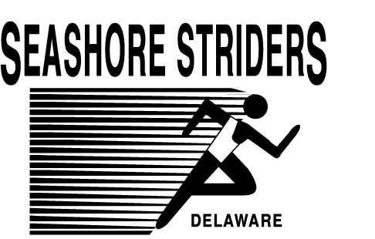


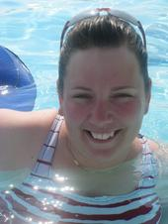

,

RACE ENTRY FORM

Name:
Address:
City/State:
Phone:
E-Mail:
Age/DOB:
Gender :
Emergency
Contact:

Waiver
I know that a run event can be a dangerous activity and I will not enter unless I am properly trained. I waive and release the Seashore Striders, City of Lewes, Sussex County Paramedic Association, and all sponsors from any claims based on my participation.

SIGNATURE DATE

PARENT SIGNATURE IF UNDER 18 YR
Official use only
BIB NUMBER:

Mail completed application to:
Seashore Striders; PO Box 99; Nassau, DE 19969
Make payment to: “Seashore Striders”

Contact Race Director Tim Bamforth @ 302-644-8952
runningandracing@seashorestriders.com
www.seashorestriders.com


