2nd ANNUAL
MILTON GOVERNERS DAY
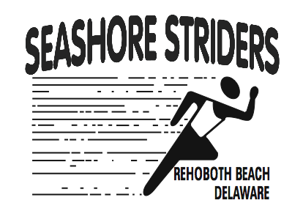 5K RUN/WALK 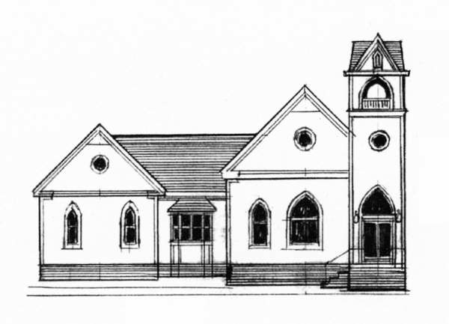 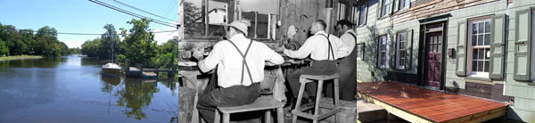

WHEN……………SATURDAY, OCTOBER 10, 2009 3:00 p.m. (Rain or Shine)

WHERE…………..Milton Historical Society (210 Union St.; Milton) Finish will be in the Milton Memorial Park
REGISTRATION…$15.00 pre-registration fee through October 8, 2008 
$20.00 race day registration from 1:30 p.m. – 2:55 p.m.

AWARDS…………Presented to the male/female 5K Overall and Master Champions as well as the top three finishers in 8 age groups from 13 & U, 14-19, 20-29, 30-39, 40-49, 50-59, 60-69, 70 & O.

AMENITIES: T-shirts guaranteed to the first 100 registered, water stop and refreshments provided, timing and finish line by Seashore Striders Race Production, Inc.; Proceeds to benefit The Milton Historical Society; Post race award ceremony at the Milton Memorial Park
RACE DIRECTOR: Tim Bamforth - Seashore Striders Race Productions 302-644-8952,  runningandracing@seashorestrider.com www.seashorestriders.com

RACE INFORMATION – CALL (302) 644-8952
Mail entry form/payment to: Milton Governers Day run/walk; PO Box 99; Nassau, DE 19969
Make Checks Payable to: “Milton Historical Society”
----------------------------TEAR HERE------------------------TEAR HERE-----------------------------

Name: __________________________________________________ Age ______ Sex ___M ___F

Address: _____________________________________________ City _______________________

State: ____ Zip ________ Phone # _____________ T-shirt _____SM _____MD _____ LG ____XL

Check which Race: _____5K Run _____1 Mile Walk
Release of Liability
I know that running a race is a potentially hazardous activity. I should not enter and run unless I am medically able and properly trained. I agree to abide by any decision of a race official relative to my ability to safely compete and run. I assume all risks associated with running in this event including but not limited to: falls, contact with other participants, the effects of the weather, including cold, high heat and/or humidity, traffic and the conditions of the road, all risks being known and appreciated by me. Having read this waiver and knowing these facts and in consideration of you accepting my entry, I, for myself and anyone entitled to act on my behalf, waiver and release: The Seashore Striders Running club, The Town of Milton, DE, The State of Delaware, Milton Historical Society, and all sponsors, their representatives and successors from claims arising from my participation in this event even though that liability may arise out of carelessness on the part of the persons named in this waiver.
SIGNATURE: __________________________________________________ DATE: ___________
PARENT SIGNATURE: (UNDER 18) _______________________________DATE:____________
Milton Historical Society| 210 Union Street, Milton, DE 19968 | info@historicmilton.org

