WHERE IS REHOBOTH BEACH?

From Baltimore… 120 miles (2:36 hrs.)
From Washington D.C…. 123 miles (2:46 hrs.)
From Philadelphia… 121 miles (2:27 hrs.)
Norfold, VA… 168 miles (3.46 hrs.)
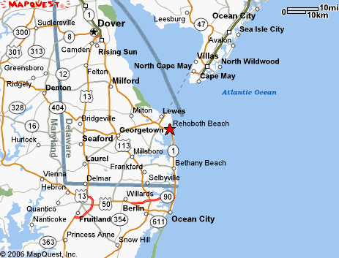
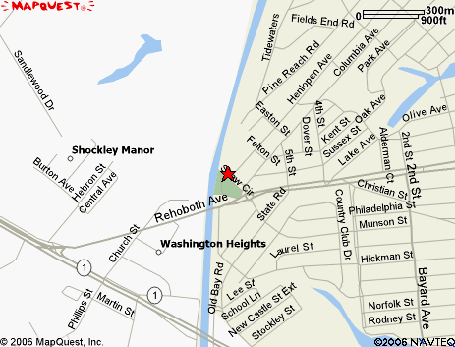
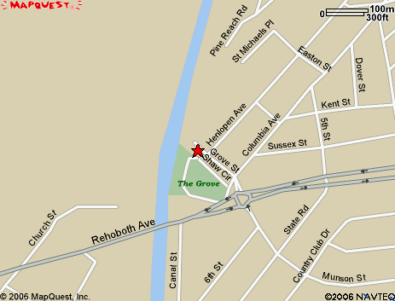

THE SEASHORE STRIDERS PRESENT…
20th ANNUAL

2009
SEAWITCH
FALL 5K CLASSIC
& 1 mile spook walk

OCTOBER 25, 2009
9 A.M.
THE GROVE PARK
REHOBOTH BEACH, DELAWARE

…Dare to race
THE SEAWITCH



Don’t forget the popular costume contest!


Frightening Race Information

When: Sunday, October 25, 2009

Time: 9 a.m. start

Distance: Run- 5000 meters; 3.1 miles
Fright Walk- 1.0 miles

Registration: $15 Early Bird Rate → Fri., 10/1
$20 Late Reg. Rate → Sat., 10/24
$25 Race-Day Rate →7:30-8:55 am

Online Registration: www.active.com

Awards: -Awards presented to the Overall, Masters, and top 3 in 14 age groups from 9 & U to 70 & O.
-Top 3 Clydesdale & Filly Runners
LONG SLEEVE T-Shirts guaranteed race-day to first 200 entrys
*Bonus- $100 for new Course Record; $50 for new Seawitch Record

Costume Contest: Keep the Seawitch tradition alive by racing in costume. Six (6) awards presented to the following:
1st, 2nd, 3rd , best group, family, child
Costume Parade at 8:45 am @ SM Pavilion.

Course Records:
Male- Scott Winnier 15:17 (99)
Female- Sonja Friend Uhl 17:03 (97)

Seawitch Records:
Overall Male- Doug Mock 15:28(92)
Overall Female- Karen Ardis 18:15 (91)
Master Male- Michael Bressi 16:31 (97)
Master Female- Maureen Hall 19:50 (06)

Race Director: Tim Bamforth
runningandracing @ seashorestrider.com

Race Information: 302-644-8952 or
www.seashorestriders.com



U S A C F R F EVENT

Dare to Enter

NAME___________________________Age_____

Address___________________________________

City_______________State______Zip__________

E-Mail____________________________________

Phone #___________________________________

T-Shirt: ___YLG, ___SM, ___MD, ___LG, ___XL

Gender: _____Male _____Female

Event: ___Spooky 5k Run; ___ 1m Fright Walk

Division: ____OPEN M/F, _____Clydesdale (200+)
_____Filly (150+)

WAIVER
I know that competing in a 5K Run/Walk can be a hazardous activity. I should not enter unless I am medically able and properly trained. Having read this waiver, I for myself and anyone acting in my behalf, waive, The Seashore Striders, Road Runners Club of America, City of Rehoboth, Rehoboth Beach Chamber, State of Delaware and all sponsors from all claims and liabilities resulting in my participation in this event.

Signature___________________________________

Parent Signature_____________________________

MAIL TO: PO BOX 99; NASSAU, DE 19969

To keep all runners safe on the course, the Road Runnners Club of America discourages the use of jogging strollers, headphones, pacing bikes, and animals during the 5k event. Thank You S.S.E.P.





