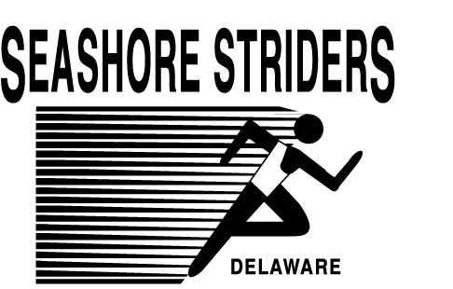
“Running & Racing at the BEACH”
SEASHORE STRIDER EVENT PRODUCTION

2010 DELAWARE SEASHORE STRIDERS – FALL SCHEDULE

DATE RACE NAME LOCATION

Sunday, September 19, 2010 @ 8:30am | 6th Cannonball 5k run/walk & 1m walk | Lewes Historical Society; Lewes, DE
Saturday, September 25, 2010 @ 9:00am | 7th Remembrance 5k run & 2m walk | Federalsburg Marina Park; Federalsburg, MD
Sunday, September 26, 2010 @ 8:00am | 5th Dogfish Dash 5k/10k…RACE IS FULL FOR 2010 at 1500 | See you in 2011…
Friday, October 1, 2010 @ 5:30pm | 3rd Dolphin Dash 5k run/walk | Shields Elementary School; Lewes, DE
Saturday, October 2, 2010 @ 8:30am | 7th N.D.H.S. Eagle 5k Run & 1m walk | Hurlock Elementary School; Hurlock, MD
Sunday, October 3, 2010 @ 9:00am | 3rd Giggle Medic 5k run/walk | Cape Henlopen High School – Lewes, DE
Sunday, October 17, 2010 @ 9:00am | 5th Bayfront at Rehoboth 5k run/walk | Bayfront; Lewes/Angola, DE
Saturday, October 23, 2010 @ 8:00am | Inaugural Raven Classic XC 5k run | S.T.H.S.; Georgetown, DE
Sunday, October 24, 2010 @ 9:00am | 2nd Habitat Halloween Dash 5k Run & 1m walk | Federalsburg, MD
Sunday, October 31, 2010 @ 9:00am | 21st Seawitch Fall 5k Classic & 1m spook walk | Grove Park; Rehoboth Beach, DE
Saturday, November 6, 2010 @ 9:00am | 2nd Tails on the Trail 5k run & 1m walk | Cape Henlopen State Park; Lewes, DE
Sunday, November 14, 2010 @ 1:00pm | 8th Mariner Bethel 7 mile & 5k Trail runs | Camp Barnes; Bethel, DE
Saturday, November 27, 2010 @ 9:00am | Inaugural Huffin’ Puffin’ & Racing for Stuffin’ 5k Run | Grove Park; Rehoboth Beach, DE

Sunday, November 28, 2010 @ 9:00am | 8th Sea Colony Turkey Trot 5k run & walk | Sea Colony Fitness Ctr; Bethany Beach, DE
Saturday, December 4, 2010 @ 10:00am | 5th Seashore Snowball 5k run & 1m walk | Pier, Cape Henlopen State Park; Lewes, DE
Saturday, December 11, 2010 @ 7:00am | 3rd R.B.R.C. Seashore Marathon & ½ Marathon Classic | R.B.R.C.; Rehoboth Beach, DE
Friday, December 31, 2010 @ 12:00pm | 8th Race into the New Year 5k & kid’s dash | R.B.R.C.; Rehoboth Beach, DE

P.O. Box 99; Nassau, Delaware 19969 (302) 644-8952
Be sure to check our website and hotline for any changes and upcoming information regarding events through Dec. 2010.
The Seashore Striders hope you join us on the starting line for many of our 60+ events we manage on Delmarva
Director Tim Bamforth; tim@seashorestrider.com
www.SEASHORESTRIDERS.COM
SEASHORE STRIDER EVENT PRODUCTION


