MEET INFORMATION
When: Sunday, November 6, 2011 @ 10:00 a.m. (Course Walks– 9:00 a.m. / Coaches Meeting– 9:45 a.m.) No Time Schedule – race order…girl to boy, young to old)
Where: Killens Pond State Park; Felton, Delaware
Age Grp/Distance: Age as of 12/31/11 **Mighty Mites … 5 & U yrs. – 1k or .62 miles (Born 2006+)
Primary … 6 to 8 yrs. – 2k or 1.24 miles (Born 2003-2005)
Bantam … 9 & 10 yrs. – 3k or 1.86 miles (Born 2001-2002)
Midget … 11 & 12 yrs. – 3k or 1.86 miles (Born 1999-2000)
Youth … 13 & 14 yrs. – 4k or 2.48 miles (Born 1997-1998)
15-16 & 17-18 Divisions
Due to the proximity of high school states meets to the CCCNYC, there is no qualifying for teams in the 15-16 and 17-18 age divisions. Any team composed of athletes from the same state who are all in the same age group may enter the meet provided they obtain YES-Athletics team memberships and YES-Athletics individual memberships.
** This Div. does not qualify for Nationals
- Meet Director has the right to combine age groups or races based on number of entries.
Awards: will be presented to the top (M/F) team in each of the five(5) divisions as well as trophies & medals to the top 20 finishers in each race.
Meet Director: Tim Bamforth- Seashore Striders
Games Committee: Tim Bamforth, Dan MacElrevey, Chris Kenton, Mary Ellen Malloy, Dave Ritter
More Info on CCCNYC: Visit www.youthcrosscountry.org
Entry Info: $10.00 through October 31, 2011 $12.00 from 11/1 through 9 p.m. on 11/5 *Mail-in registration is recommended by 10/31 NO RACE DAY REGISTRATION
Address your Cashier Check or Money Order to: “Seashore Striders”
Mail completed entry form by Oct. 31st to: Seashore Strider XC, P.O. Box 99, Nassau, DE 19969
Overnight/USP/Fed Ex Mail sent to: Seashore Striders/ Tim Bamforth, 9 Gander Lane, Lewes, DE 19958
- All entrants must have a complete entry form.
- TEAMS must fill out a team declaration form due to the scoring tent 30 min. before race. No Exceptions. Teams- Minimum is 5 and max is 8 runners.
Qualification: Starting with Primary- The top (20) finishers by age in each race, who are not members of a qualifing team, qualify for the CCC National Youth Championships. All members of the top (3) teams also qualify. Performances under a time standard also will qualify. Standards listed at www.youthcrosscountry.org *All teams must be registered with YES Athletics.
Proof of Age & Membership: Participants may be required to show an acceptable proof of age, a birth certificate, drivers license, or another form proof of age. Your YES membership number must be provided on your entry form. Be prepared to show a YES CARD. *No athlete permitted to run wthout 2011 YES Card.

(Please Print)
ENTRY FORM
Name_____________________________________
Address____________________________________
___________________________________________
YES # __________________________Gender_____
D O B____/____/____ Phone #________________
E-MAIL____________________________________
Check: __M.MIT, __PRIM, __BAN, __MID, __YTH
Check: ____MALE ____FEMALE
Club/Team _________________________________
Name of Coach___________________________________
Waiver I release the Seashore Striders, KPSP, State of DE. From all claims regarding this event and my son/daughter (s) participation.
___________________________________________ Parent Signature Meet Information: Call the S.S. Office @ 302-644-8952 E-Mail Tim Bamforth at tim@seashorestrider.com
- Refreshments…, T-Shirts will be on sale - Restrooms available; no locker rooms or showers - Delaware State Park Charge will be in effect through November 30, 2011. $3 in-state & $6 out of state charge - Course run on grass, trails, & woods, w/ some hills
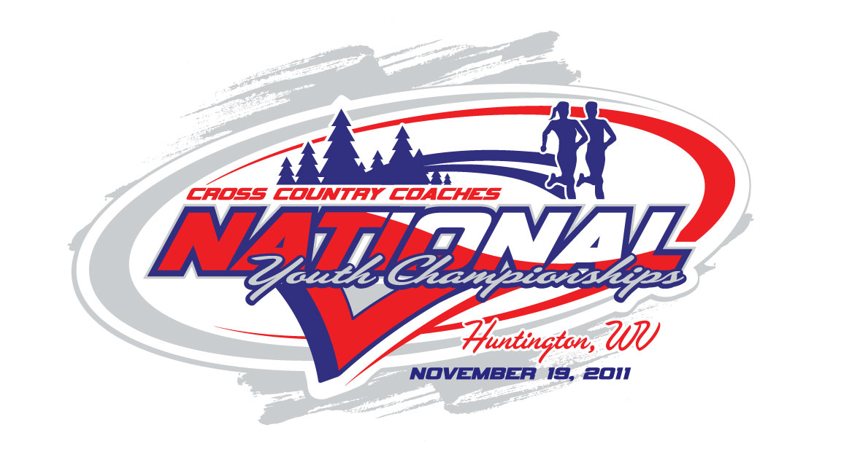2011 Cross Country Coaches National Youth Championships- Huntington, WV - November 19, 2011
WHERE IS KILLENS POND STATE PARK ?? GPS Address: 5025 Killens Pond Road, Felton, DE 19943
This is a great website which shows you directions to the park as well as details inside the park. http://www.destateparks.com/k
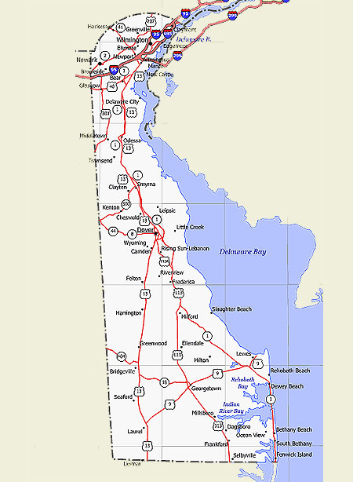
HOTELS
REGIONAL XC MEET
Killens Pond S.P.
Total Est. Time: 1 hour, 46 minutes (Phil, PA) Total Est. Distance: 92.21 miles
XC COACHES EASTERN REGIONAL CROSS COUNTRY CHAMPIONSHIPS

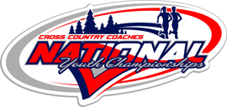
2011
EASTERN REGIONAL CROSS COUNTRY CHAMPIONSHIPS
SUNDAY, NOVEMBER 6, 2011
KILLENS POND STATE PARK
FELTON, DELAWARE
A quality end of the season meet for youth ages 14 & U and a chance to race in December at the XC Coaches National Championships in Huntington, WV


