MEET INFORMATION
When: Sunday, November 11, 2012 @ 10:30 a.m. (Course Walks– 9:00 a.m. / Coaches Meeting– 10:00 a.m.) No Time Schedule – race order…girl to boy, young to old)
Where: Killens Pond State Park; Felton, Delaware
Age Grp/Distance: Age as of 12/31/12 **Mighty Mites … 5 & U yrs. – 1k or .62 miles (Born 2007+)
Primary … 6 to 8 yrs. – 2k or 1.24 miles (Born 2004-2006)
Bantam … 9 & 10 yrs. – 3k or 1.86 miles (Born 2002-2003)
Midget … 11 & 12 yrs. – 3k or 1.86 miles (Born 2000-2001)
Youth … 13 & 14 yrs. – 4k or 2.48 miles (Born 1998-1999)
15-16 & 17-18 Divisions
Due to the proximity of high school states meets to the CCCNYC, there is no qualifying for teams in the 15-16 and 17-18 age divisions. Any team composed of athletes from the same state who are all in the same age group may enter the meet provided they obtain YES-Athletics team memberships and YES-Athletics individual memberships.
** This Div. does not qualify for Nationals
- Meet Director has the right to combine age groups or races based on number of entries.
Awards: will be presented to the top (M/F) team in each of the five(5) divisions as well as trophies & medals to the top 20 finishers in each race.
Meet Director: Tim Bamforth- Seashore Striders
Games Committee: Tim Bamforth, Dan MacElrevey, Sam Wylie, Mary Ellen Malloy, Dave Ritter
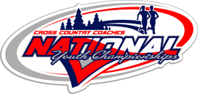
More Info on CCCNYC: Visit www.youthcrosscountry.org
Entry Info: $10.00 through October 31, 2012 $12.00 from 11/1 through 9 p.m. on 11/9 *Mail-in registration is recommended by 10/31 NO RACE DAY REGISTRATION
Address your Cashier Check or Money Order to: “Seashore Striders”
Mail completed entry form by Oct. 31st to: Seashore Strider XC, P.O. Box 99, Nassau, DE 19969
Overnight/USP/Fed Ex Mail sent to: Seashore Striders/ Tim Bamforth, 9 Gander Lane, Lewes, DE 19958
- All entrants must have a complete entry form.
- TEAMS must fill out a team declaration form due to the scoring tent 30 min. before race. No Exceptions. Teams- Minimum is 5 and max is 8 runners.
Qualification: Starting with Primary- The top (20) finishers by age in each race, who are not members of a qualifing team, qualify for the CCC National Youth Championships. All members of the top (3) teams also qualify. Performances under a time standard also will qualify. Standards listed at www.youthcrosscountry.org *All teams must be registered with YES Athletics.
Proof of Age & Membership: Participants may be required to show an acceptable proof of age, a birth certificate, drivers license, or another form proof of age. Your YES membership number must be provided on your entry form. Be prepared to show a YES CARD. *No athlete permitted to run wthout 2012 YES Card.

(Please Print)
ENTRY FORM
Name_____________________________________
Address____________________________________
___________________________________________
YES # __________________________Gender_____
D O B____/____/____ Phone #________________
E-MAIL____________________________________
Check: __M.MIT, __PRIM, __BAN, __MID, __YTH
Check: ____MALE ____FEMALE
Club/Team _________________________________
Name of Coach___________________________________
Waiver I release the Seashore Striders, KPSP, State of DE. From all claims regarding this event and my son/daughter (s) participation.
___________________________________________ Parent Signature Meet Information: Call the S.S. Office @ 302-644-8952 E-Mail Tim Bamforth at tim@seashorestrider.com
- Refreshments & T-Shirts will be on sale - Restrooms available; no locker rooms or showers - Delaware State Park Charge will be in effect through November 30, 2012. $3 in-state & $6 out of state charge - Course run on grass, trails, & woods, w/ some small hills
 Cross Country Coaches National Youth Championships Terre Haute, IN - December 1, 2012 Welcome to Cross Country Town USA! The Lavern Gibson Championship Cross Country Course was designed for the sole purpose of Cross Country. Located just outside of Terre Haute, Indiana-- It is "one of the most spectator friendly distance running courses in the world".
WHERE IS KILLENS POND STATE PARK ?? GPS Address: 5025 Killens Pond Road, Felton, DE 19943
http://www.destateparks.com/k
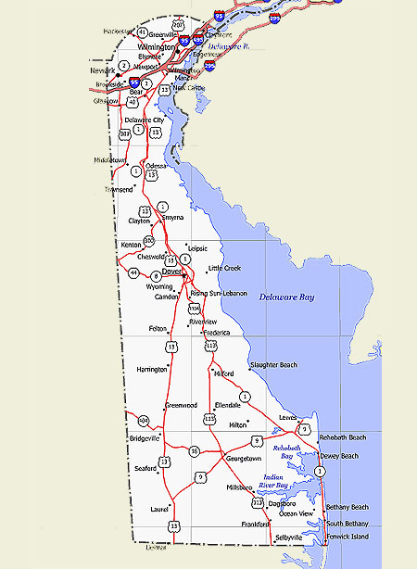
HOTELS
EAST REGIONAL XC MEET
Killens Pond S.P.
CROSS COUNTRY COACHES EASTERN REGIONAL CROSS COUNTRY CHAMPIONSHIPS

2012
EASTERN REGIONAL CROSS COUNTRY CHAMPIONSHIPS
SUNDAY, NOVEMBER 11, 2012
KILLENS POND STATE PARK
FELTON, DELAWARE
A quality end of the season meet for youth ages 14 & U and a chance to race in December at the XC Coaches National Championships in Terre Haute, IN “Home of the College National Championships”

