RACE INFORMATION

When: Sunday, October 11, 2009 @ 9 a.m.
Registration begins at 7:30 a.m. at the track/Savannah Road side of C.H.H.S..

Where: Cape Henlopen High School, Lewes DE.

Distance: 5K Paved Run & Walk

Registration: $20 Pre-Registration -> 10/5/09
$25 Race-Day Registration 7:30-9 a.m.
Participants can also register online through www.active.com searching “Giggle Medic Run”

Awards: Overall, Masters, & Top 3 finishers in the following 9 age groups: 9 & U, 10-13, 14-19, 20-29, 30-39, 40-49, 50-59, 60-69, 70+
Stephanie Callaway Spirit Award
(1st male & female Paramedic)

Amenities: multi-colored long sleeve t-shirt; surf bagels, timing & results by the Seashore Strider Event Production, Inc.

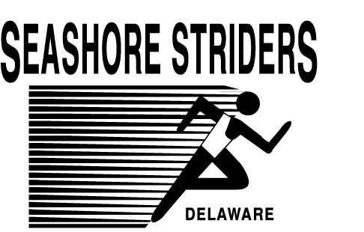


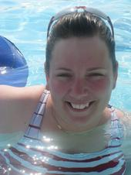

,

RACE ENTRY FORM

Name: ______________________________

Address: __________________________________

City: _______________________ST:______

Zip: ___________ Phone#:_______________

Age on Race-Day:_________

E-Mail:_______________________________

Emergency Contact:____________________

Please Check: _____Male _____Female

Waiver

I know that a run event can be a dangerous activity and I will not enter unless I am properly trained. I waive and release the Seashore Striders, City of Lewes, Sussex County Paramedic Association, and all sponsors from any claims based on my participation.

Signature_____________________________________

Mail completed application to:
Seashore Striders; PO Box 99; Nassau, DE 19969
Make payment to: “Seashore Striders”

Contact Race Director Tim Bamforth @ 302-644-8952
runningandracing@seashorestriders.com
www.seashorestriders.com

Presents

"Giggle Medic" 5K Run



When we get sponsors their logo will be placed here!!


