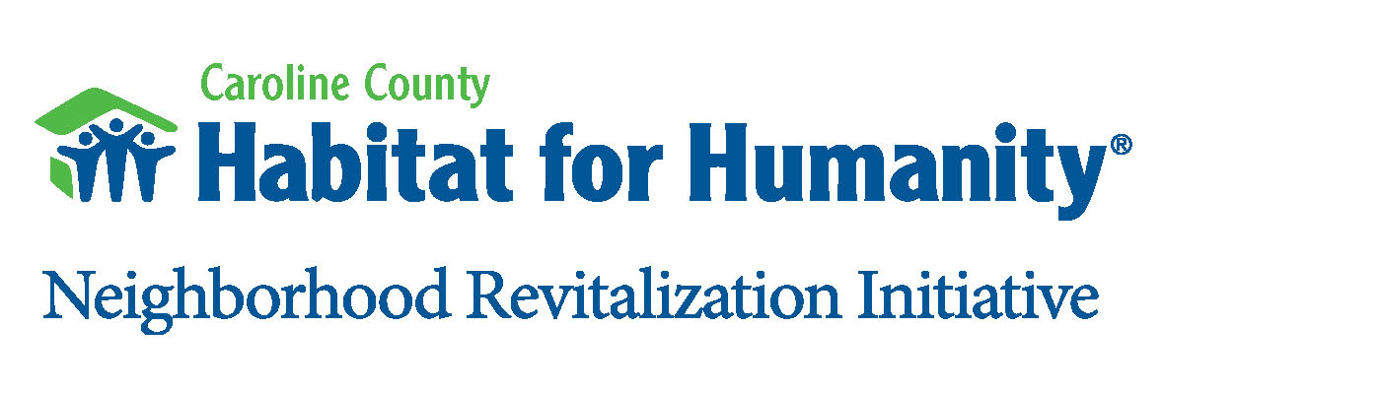

HABITAT HALLOWEEN
3rd Annual-5K DASH/ 1 Mile Fun Walk

A CAROLINE COUNTY HABITAT FOR HUMANITY EVENT, to benefit our mission to provide decent, affordable, energy-efficient homes to families in Caroline County who are living in substandard housing.
Sunday, October 23, 2010 @ 9 a.m.
(Registration begins at 7:30 a.m.)
Where: Lake Creek Court, Federalsburg, Maryland
Registration: Early Registration: $20.00 through Friday, 10/14 & guaranteed Race T-Shirt
Late Registration: $25.00 after 10/15, through Race Day
Sleepwalker Registration Option: $25 to stay in bed, no sweat and contribute to the good work of Caroline County Habitat for Humanity.
For more information or to register online, go to www.seashorestriders.com
Registration forms can be downloaded from the Habitat website at www.carolinehabitat.org.
REGISTER EARLY!
Awards: Overall and Master Champions and top three finishers in each age group in the 5K race.
Course: Out and back course through residential neighborhoods and the footpath along the Marshy Hope Creek.
Amenities: Custom design T-shirts guaranteed to Early Registration, festive give-aways, mile marks, display clock, water stop, door prizes and refreshments. Finish-line, course set-up and measurement handled by Tim Bamforth, Seashore Striders Event Production, Inc.
Race Coordination: Beth McCullough
For Information: Call Beth McCullough at (410) 479-2621 or (410) 924-4441.
More info on this 501C3 Non-profit Corp, visit our web site - www.carolinehabitat.org.

Habitat Halloween 5K Registration Form
Make Checks Payable to: Caroline County Habitat for Humanity.
Mail form and fee to: CCHFH, P.O. Box 392, Denton, MD 21629.

In consideration of this entry, I hereby waive for myself, my heirs, executors, administrators, any and all claims of damages I may have against Caroline County Habitat for Humanity, for any claims arising from my participation and or photos in this event.
Signature: ________________________________________Date: ______________________
Adult Signature for Under 18 ___________________________________________________
Name: __________________________________Male_____________Female ____________
Address: _____________________________________ Phone: _________________________
____________________________________________ Email _________________________
Adult Shirt Size (circle one): SM MD LG XLG XXLG
Which Activity ( √ ) : 5K Race 1 Mile Fun Walk Sleepwalker

Age Group ( √ ): 14 & under 15-19 20-29 30-39 40-49 50-59 60-69 70 & up_____ Yes! I would welcome a receipt for my tax-deductible donation to Caroline County Habitat for Humanity. The donation amount enclosed is: ____________.

