MEET INFORMATION
When: Saturday, October 23, 2010 @ 10:00 a.m. (Course Walks– 9:00 a.m. / Coaches Meeting– 9:45 a.m.) No Time Schedule – race order…girl to boy
Where: Sussex Tech High School, Georgetown, De.
7 Races:
8 a.m. Start…5k Open (calling coaches & alumni)
10 a.m. Start…High School Varsity Girls…your best 7
…High School Varsity Boys…your best 7
…High School J.V. Girls…rest of your team
…High School JV Boys…rest of your team
…Middle School Open Girls…8th gr. & U
…Middle School Open Boys…8th gr. & U
…Award Ceremony approximately 1 p.m.
Awards: will be presented to the top three (M/F) teams in each of the four(4) H.S. Races as well as trophies & medals to the top 20 finishers in each race. Finisher Ribbons to all participants.
Meet Director: Tim Bamforth- Seashore Striders
Games Committee: Tim Bamforth, Dan MacElrevey, & Lou Nicoletti
Team Entry Info: $50.00 / H.S. Varsity Team per gender $50.00 / H.S. J.V. Team per gender $25.00 / Middle School Team per gender $10.00 / Individual Entry to any race *five runners make a scoring team
Entries due on OCTOBER 15, 2010 at Midnight
** Coaches…Along with your completed application & payment, PLEASE E-MAIL me your roster per race entered no later than October 15th.
Address your Cashier Check or Money Order to: “Seashore Striders”
Mail completed entry form by October 15th to: Raven XC Classic, P.O. Box 99, Nassau, DE 19969
Overnight/USP/Fed Ex Mail sent to: Raven XC Classic/ Tim Bamforth, 9 Gander Lane, Lewes, DE 19958
- All entrants/teams must have a complete entry form.
Packet Pick-up: Saturday, October 23rd from 8-9 a.m. at the Registration Tent near the finish line.
Middle School: Team Scores will not be kept due to DIAA regulations. The race will be run as an open event.

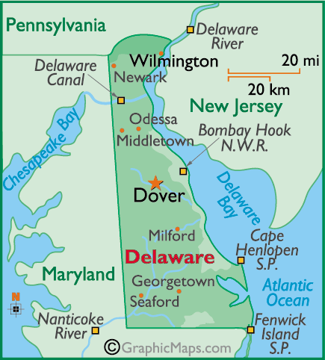
Raven XC Classic H.S.

Sussex Tech H.S.
(Please Print) Team Name__________________________________ Coach Name, Number, & Email___________________ ____________________________________________Please check which teams/races you are entering.
ENTRY FORM
____…High School Varsity Girls…your best 7 ($50)
____…High School Varsity Boys…your best 7 ($50)
____…High School J.V. Girls…rest of your team ($50)
____…High School JV Boys…rest of your team ($50)
____…Middle School Open Girls…8th gr. & U ($25)
____…Middle School Open Boys…8th gr. & U ($25)
Individual Application: Name______________________________________
Age_____ Check: ____MALE ____FEMALE
D O B____/____/____ Phone #________________
E-MAIL______________________________________
Race # & Name_______________________________
Team _______________________________________ Name of Coach___________________________________ Waiver I release the Seashore Striders, Sussex Tech H.S., State of DE. From all claims regarding this event and my son/daughter (s) participation.
____________________________________________ Parent Signature
Meet Information:
Because of the size & safety of the course, we will limit the H.S. Races to the first 12 teams that enter the meet. We will contact any team that did not make the cutoff with-in 24 hours of receiving their team entry.
Call the S.S. Office @ 302-644-8952 or E-Mail Tim Bamforth at tim@seashorestrider.com
- Refreshments & T-Shirts will be on sale - Portable Restrooms available; no locker rooms or showers - Athletes, coaches, and parents/spectators are to remain on the south side or course side of Georgetown/Laurel highway throughout the entire meet. Sussex Tech school is off-limits. Open & individual participant parking will be on the course side, while bus drivers will drop their team to the course side and bus parking will be on the school side.
- Course run on grass & woods, w/ narrow trails.
WHERE is Sussex Tech High School ?? GPS Address: Sussex Tech High School 17099 County Seat Hwy - P.O. Box 351 Georgetown, DE 19947

RAVEN XC CLASSIC
RAVEN XC CLASSIC

2010
Inaugural RAVEN CLASSIC CROSS COUNTRY INVITATIONAL
SATURDAY, OCTOBER 23, 2010
SUSSEX TECH HIGH SCHOOL
GEORGETOWN, DELAWARE
This meet is sanctioned for DIAA Delaware Schools, Maryland Schools, and Pennsylvania schools.


